Summary of work completed for Assignment 2 Introduction to IT, Class A Group 8
“The Transistor Team”

Team members: Daniel Mammone, Harley Tuleja, Liam Hackett, MaryJane Amos, Steven Flanigan.

Introduction.

Contained within this report is the required information for assignment 2 with external links to our group website(https://harleytee.github.io/IntroToITASS2/) which contains links to our personal websites.

The report will be set out in sections each addressing the following criteria:
- Team Profile which includes Team name and summarised personal information, a more in depth look into individual team members profiles can be found through our team website.
- An essay on our team’s ideal jobs which will include insights gleaned through burning glass data as to whether our selections are current with today’s employment needs within the IT sector. Within this section you will also find a comparison of each individuals preferred jobs.
- Four separate essays written by different members of the group covering Autonomous Vehicles, Cloud Computing, Machine Learning and Robotics.
- A write up from an interview with a professional in the IT sector.
- A summary of our groups project idea with a detailed timeline of how we plan to achieve this. With a link to our project site for further reading.
- A reflection of how well our group worked together, including what could be improved and what we did well along side individual reflections.
The report will be set out in this PDF document to aid in the uploading and marking process required by RMIT.

Team Profile

Our team of 5 comes from varied backgrounds with varied experience in Information Technology(IT) you can find our profile here. We decided on the name “The Transistor Team” as there are many transistors in the IT world and it is phonetically coherent.
All the visuals for our tests are included in our personal websites attached to our profiles.

Daniel Mammone - S3817613
S3817613@student.rmit.edu.au
I live in Melbourne with my partner. I work full time in truck parts sales but hoping to change that it an IT role soon. I’ve always liked technology and what it is capable of. I love playing video games and watching movies and TV series. I like seeing live bands either at concerts or festivals and I love my cars.
Preferred learning style-Tactile/Kinesthetic
Myers-Briggs - INTJ
Big Five personality test: https://daniel2693.github.io/big_five.html

Harley Tuleja – S3812513
S3812513@student.rmit.edu.au
I am a new father with a keen interest in IT, Mountain Sports and computer games. I live in Launceston Tasmania and have travelled the world, my personal personal profile is here and within that website you will find out more about me.
Myers-Briggs – INFP-T The Mediator
Learning Style Audio:35% Visual:35% Tactile:30%
Learning Style(Creativity) – 59.96(average = 63.3)

Liam Hackett - S3574031
S3574031@student.rmit.edu.au
Currently living in Sydney in the Northern Beaches with my partner and my dog. I’m working full-time managing a Gym and studying on the side. My current degree is a Bachelor of Business (Logistics and Supply Chain Management. I was working in the Supply Chain/Logistics field, focusing on Purchasing and Procurement before I took my newest role. My partner is from Brazil so I am learning Portuguese on the side when I find the time. The following link is where you can find more information on me https://liamblair87.github.io/
Myers-Briggs - ISFP Introvert(3%) Sensing(9%) Feeling(19%) Perceiving(25%)
Creativity Test - Learning Style(Creativity) – 57.38 (Typical = 63.3)
Learning Style Test - Mind - 43%/57% Extroverted/Introverted.
Energy - 67%/33% Intuitive/Observant
Nature - 39%/61% Thinking/Feeling
Tactics - 43%/57% Judging/Prospecting
Identity - 29%/71% Assertive/Turbulent

Mary-Jane Amos - S3817195
S3817195@student.rmit.edu.au
I’m a 22 year old girl with an interest in all things pertaining to science from biological to technological! I love to learn and I love to help people with what I’ve learnt! Through these web pages I hope you are able to learn more about myself here and this team.
Myers-Briggs – INFJ-T
71% introverted, 62% Intuitive, 53% feeling, 75% Judging 57% Turbulent
Learning Style: Auditory 35%, Visual 35% Tactile 30%
Steven Flanigan - S3819610
S3819610@student.rmit.edu.au

I am from Wagga Wagga NSW with a keen interest in programming as it is one of my hobbies. My other hobbies in reading, listening to music and playing games. I have very little experience in IT as I just build myself and family members computers and fix them when there are problems. My personal profile can be found here.
Myers-Briggs ESTJ
Learning Style: Auditory 40%, Visual 40%, Tactile 20%
Personality Traits(OCEAN TEST): Openness 100%,
Conscientiousness 87.5%,
Extroversion 31%,
Agreeableness 87.5%
Neuroticism 6%

Summary:
Going through the data we have noticed that we have a very broad range of personalities, while still sharing certain similarities such as creativity and adaption. We feel this works very well having a diverse team and although at times diverse personalities can lead to conflict, in our case we worked very well together.
Our learning styles varied between visual, audio, and tactile, with the majority of us having a tactile approach to learning, which in the IT industry is a good trait to have.
In our separate tests we completed, we noticed that we shared a common trait of diligence in our work. Which within IT is important as small errors in your work can lead to hours of debugging.
To sum up our group dynamic, we are varied with certain similarities and through out this project we have worked very well together setting goals and attaining them in a timely manner.

Industry Data

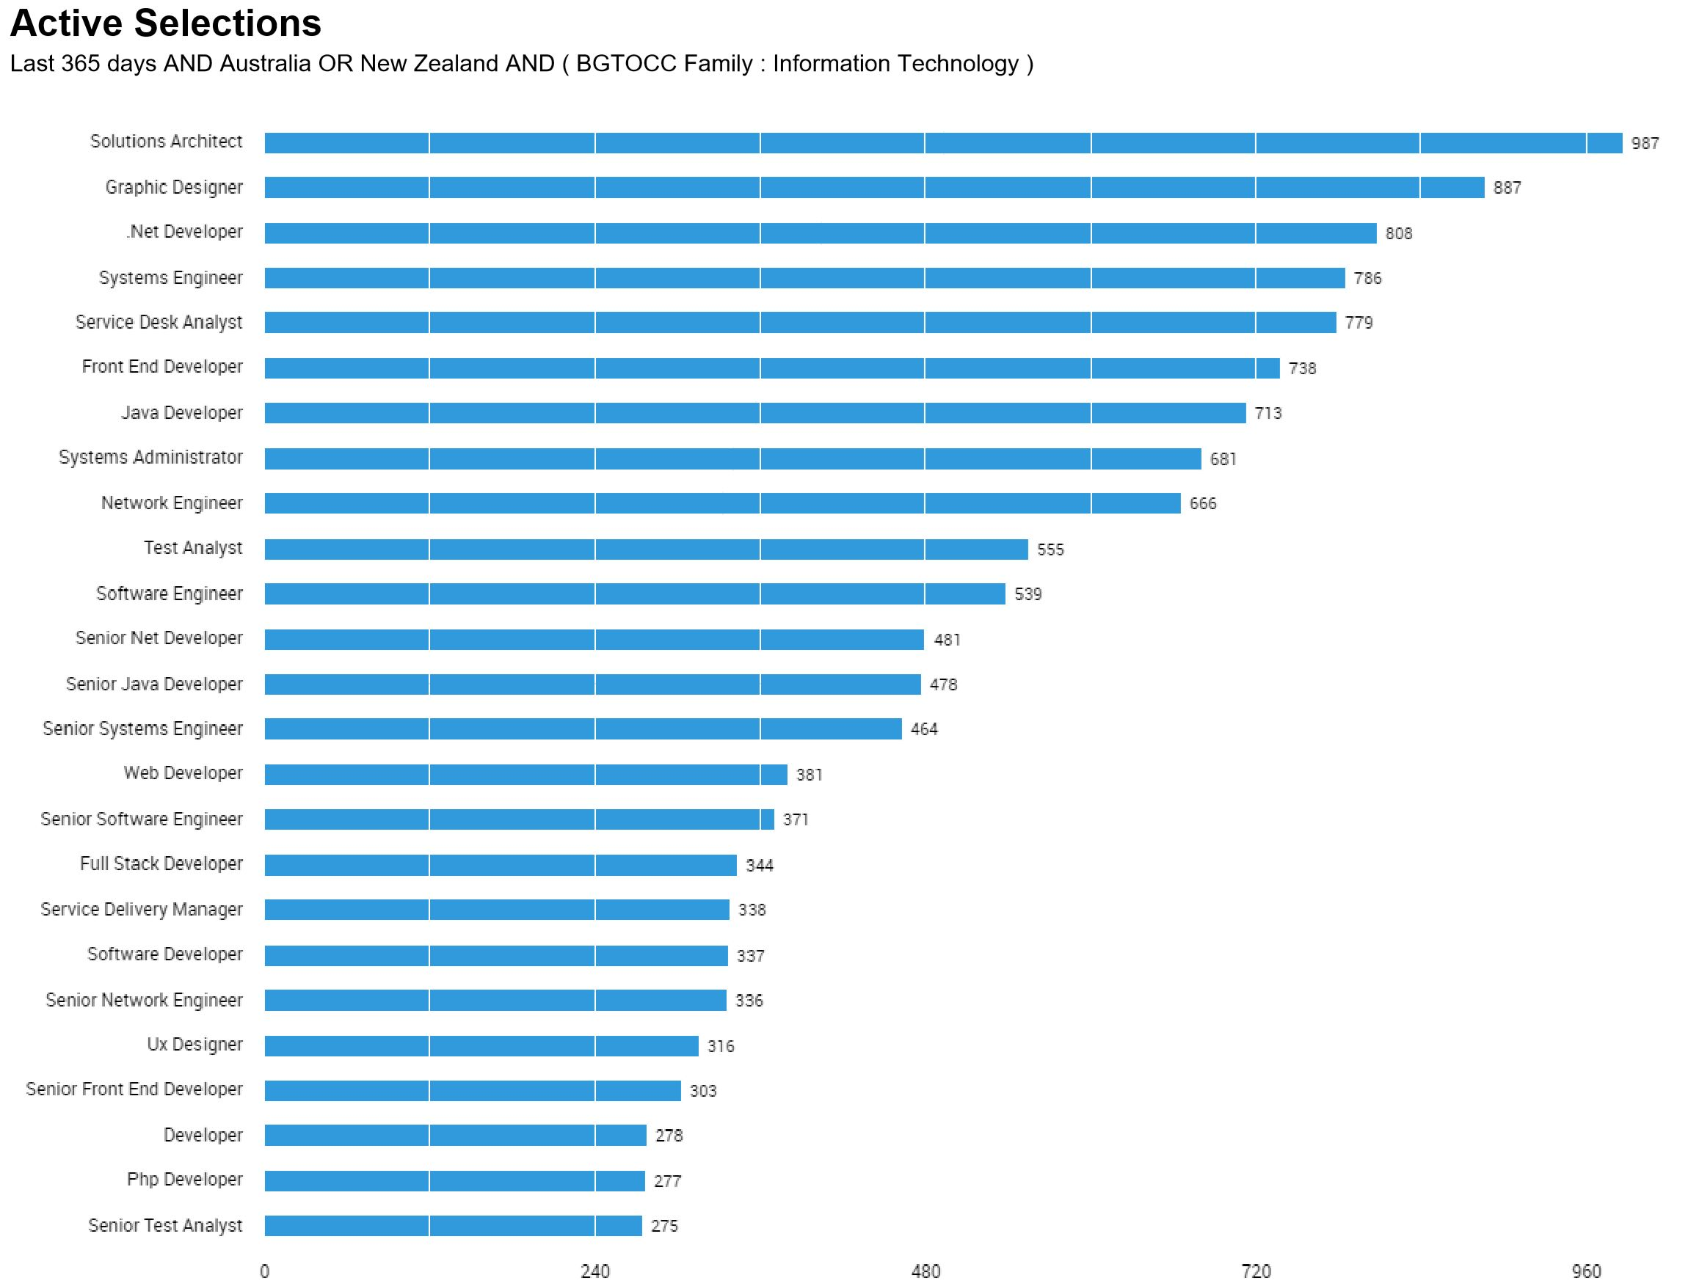(A)
Chart (A) displays the ‘top titles' within the information technology sector as of March 24th 2017.
The titles that our group have mentioned to be their ideal roles include the following:
Senior Software Engineer – Harley Tuleja
C++ Engineer - Steven Flanigan
Mobile App Developer - Liam Hackett
Network Architect – Daniel Mammone
Scientiﬁc Programmer - MaryJane Amos
Senior Software Engineer was the sixteenth most prevalent role according to the Labour Insight Data with a total of 371 job postings.
C++ Engineer was not on the top list of roles in the chart as it is a speciﬁc role and program. Software engineers however were on this list and ranked 11th with 539 job listings with that title.
Mobile App Developer as a specific role was not on the list however there were several mentions of developer positions throughout the list. They included Net, java, Senior Net, Senior Java, Web, Full stack, Software, senior front end, php and general developer roles.
Network Architect was not specified on the chart by Labour insight however the number one most sort after role was ‘solutions architect’ it had 987 roles for that title, the ninth most sort after role was Network engineering which had 666 roles being offered with that title.
Scientiﬁc Programmer was not on the list of top titles however as with this role it is closely related to developing and engineering which were all listed in the top roles according to this chart.

General Skills
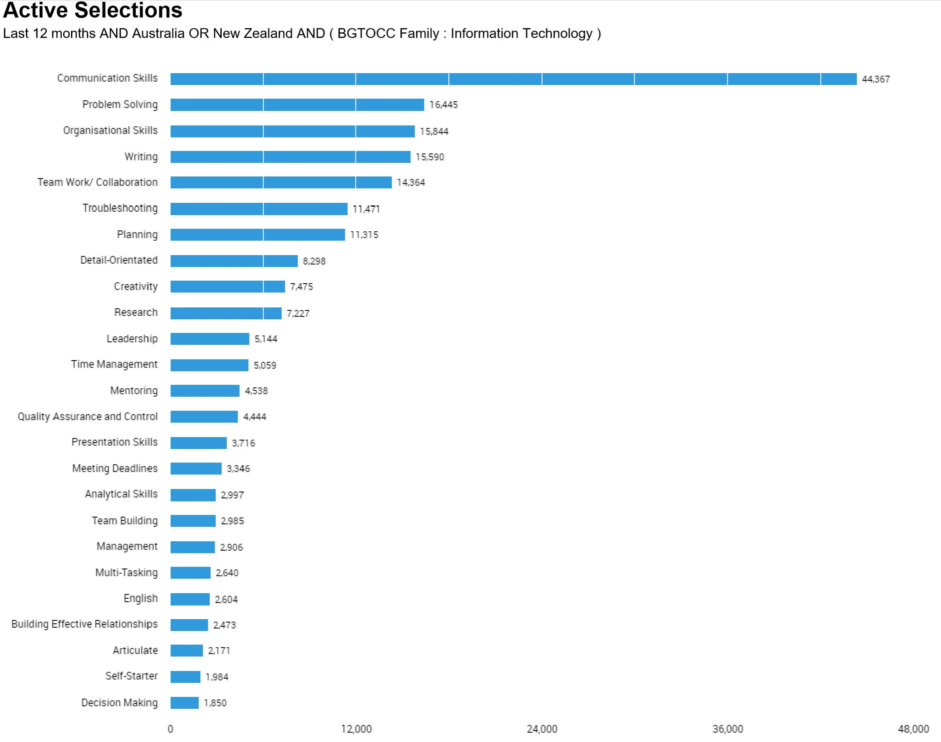(B)
Chart (B) displays the ‘Skills in Greatest Demand (Baseline Skills)' within the information technology sector as of Mar. 01, 2017 – Feb. 28, 2018.
General skills required include (Skill set):- Communication Skills, verbal and written
- Problem solving skills (debugging and forming solutions)
- Written skills
- Research
- Analytical skills
- Troubleshooting
- Team work
All our jobs had a common skill requirement of communication, employers either specified verbal communication or written communication. This was seen with the chart as over 44,000 job listings had this as their required general skill, employers really value communication as it’s necessary in any job. Problem solving was the second on this chart and had 16,445 job listings that made a mention of the skill. Problem solving in our skill set was evident however it was presented with other synonyms such as debugging or implementing solutions. It was also interesting to observe that the chart had trouble shooting listed as the sixth skill most employers look for. It can be argued that troubleshooting is another word for problem solving. The problem solving process requires trouble shooting and are connected to each other. Our skill set included trouble shooting and problem solving as mentioned earlier. Analytical skills and research were also part of our group’s skill set, it can also be argued that these skills have a relationship to the skill of problem solving as they are often used to problem solve. The most important skills that employers look for according to this chart are communication and problem solving as a high number of job listings have stated these terms in their descriptions or advertisements.
The three highest ranked general skills which are not in our required skill set are:
Organisational Skills with 15,844 jobs
Writing with 15,590 jobs
Planning with 11,471 jobs

IT Specific Skills.

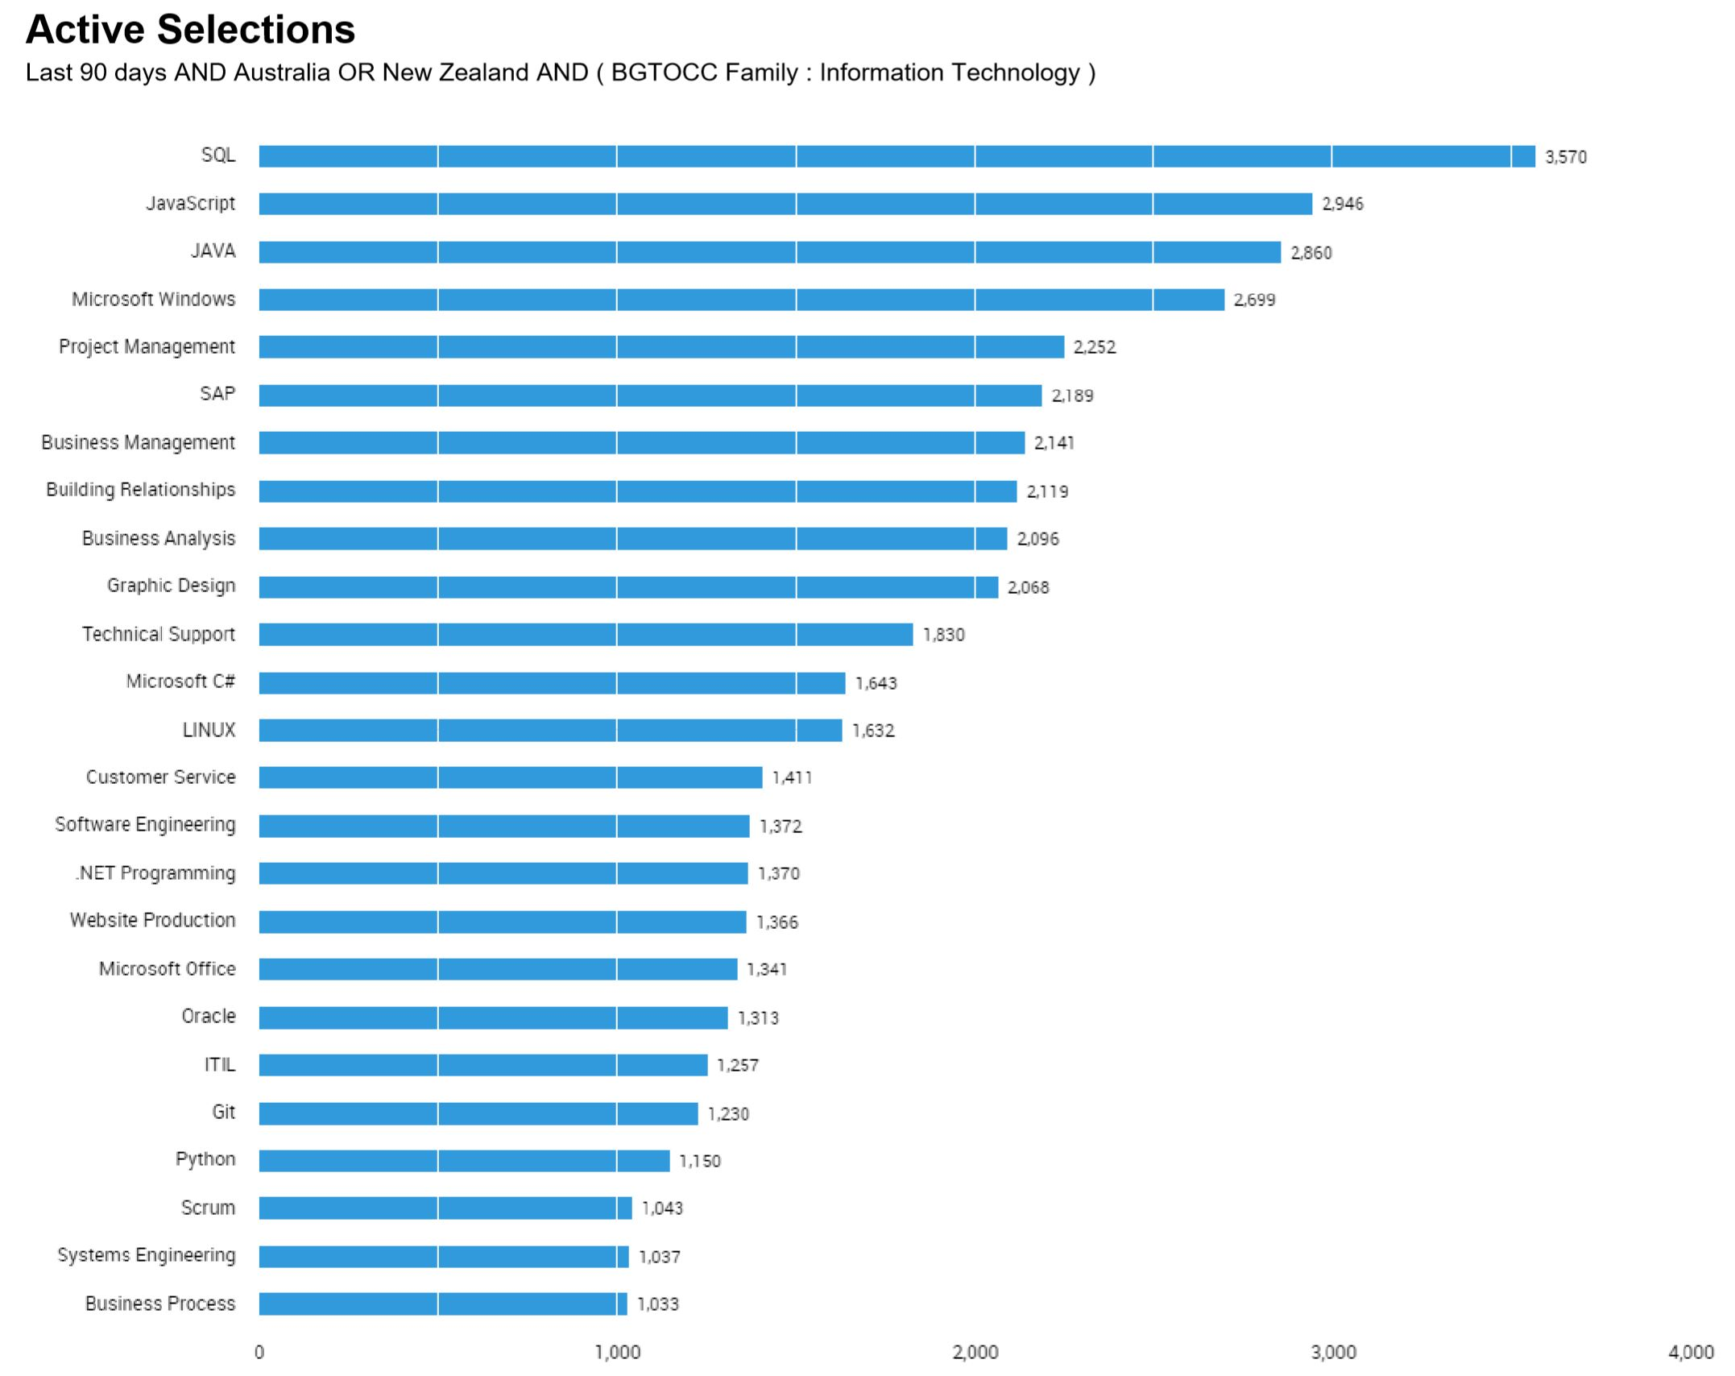(C)
Chart (C) above displays the ‘Skills in Greatest Demand (Specialised Skills)' within the information technology sector as of Dec. 24, 2017 – Mar. 23, 2018.
IT speciﬁc skills required (Skill set) - Coding
- C++
- Linux
- Python
- VMware
- SD WAN experience
- AWS
- Azure
- C#
- WPF
- MVVM
- UX design
The data chart by labour insight lists the top specialist skills in demand according to the ﬁlters applied during the search. There was a total of 27,435 jobs with these skills speciﬁc to IT. The top skill was SQL which had 3,570 job listings, none of our jobs required SQL as a specialised skill. C++ was among our skill set required for a few jobs however that skill was not on the chart there was however Microsoft C# with 1643 job listings specifying it as a required skill for the role. Linux was among the required skills for 1,632 positions, Linux by this chart is a highly sort after skill that would expand employment opportunities. Python is also a popular skill amongst employees with 1,150 job listings with this requirement. VMware was not included in this list as it is a software company that specialises in virtual machines. Familiarity with such software is not common due to it’s uniqueness to a few areas in IT. SDWAN (software-deﬁned networking in a wide area network) was also not included in the top list of required skills. AWS ( amazon web services) failed to make the list also, this may be due to it’s specificity. Azure which is a Microsoft cloud computing service was not included in this chart as well. Windows Presentation Foundation
WFP, UX design and Model–view–viewmodel (MVVM) a software architectural pattern were not among the specialised skills that most employers mentioned in their job listings.
The three highest ranked IT-speciﬁc skills which are not in our required skill set are:
SQL with 3,750 job listings
JavaScript with 2,946 job listings
JAVA with 2,860 jobs
Reflection

After looking at the burning glass data it is evident that speciﬁc jobs are more in demand than others particularly developing, analyst and engineering roles. My job title in particular was not present on this list. The title of scientiﬁc programmer is more speciﬁc to the scientiﬁc sector therefore it is not a popular ﬁeld for IT, I do see that there are aspects of the popular roles included in my ideal job such as analyses and to some degree developing. When it comes to job security and gaining employment it makes sense to consider other roles which are known to be popular and in demand, however my opinion of my ideal job has not changed. I believe it is a niche industry especially when it comes to the IT portion of science and research. This does not mean there aren’t such roles. The top or most common roles that relate to information technology are included in this list, there are so many less popular roles that didn’t make it to the list for that reason. My overall opinion about my ideal role remains unchanged however I’m now more aware that it is not as popular as other roles and may prove to be a challenge to obtain. -MJ

Even after looking through the burning glass data I am still very happy with the “ideal job” that I have found. Although being a senior software engineer is not the most sought after job according to some of the burning glass data it is still very popular with , as I believe the company values of Blizzard are in line with my own values, and that is more important to me than being in demand.
Software engineers while not the highest sought after profession according to BG they are still very high up on the list, this is encouraging as I believe that if I work towards this goal I won’t ever have to worry about work if I can’t get a job with Blizzard or a similar game developer. - Harley
Having looked at the burning glass data, I am still happy with my choice of “ideal job” as I have a huge passion for programming and would love to be a software engineer regardless of what the data shows. I love writing programs and how they come together to solve a particular problem I also like seeing how other programs were put together as to learn how to better present the code. So in my final thoughts on the data I just can't see myself doing anything else. - Steven

After going through the burning glass data, I am not worried about my job choice at all. There will always be a need for some sort of app development, whether it’s for entertainment, social, emergency services or weather. Each industry can use mobile apps to help develop and enhance their areas. This means that I will always have something new and exciting to do and will never be bored with what app I choose to pursue. - Liam

After looking at the burning Glass report I am glad to see that my ideal career path (network engineering/architect) was in the top ten most sort after job roles, it means that once I finish my university course I should be able to find a job quite quickly. There will always be a need for networks whether they are wired or wireless or for businesses or communities all around the world. This report has strengthened my passion for IT just knowing the demand is there. - Daniel

IT TOOLS

AUTONOMOUS VEHICLES -Daniel. M

An autonomous vehicle - also known as a driver-less car - is a vehicle that can sense its environment and move safely on its own with very little or even no human input. Autonomous vehicles carry several different sensors to see and sense their surroundings, which include radar, LIDAR (Light Detection and Ranging - a sensing method that uses light in the form of a pulsed laser to measure distances), GPS, odometry and inertial measurement units. An advanced onboard computer takes all the inputs from these sensors to identify the roads, road signs as well as obstacles such as pedestrians, other vehicles and roadblocks. Ideally automotive companies want to aim for level 5 automation which classifies as: “steering wheel optional” and require no human intervention at all. At this present moment in time we are at level 2, which classifies as "hands off.” At level 2, the automated system takes full control of the vehicle, however the driver must keep an eye on the road and be prepared to take control straight away if the automated system fails to respond properly. Although this level is called “hands off”, the vehicle still requires the driver’s hands to be on the wheel at all times for the system to engage.[1]

Over the next three years it’s unlikely that we will see much more advancement in autonomous passenger cars on our roads. It is likely to be decades before we reach level 5 advancement. Several car makers and technology companies have concluded that making autonomous vehicles is going to be harder, slower and costlier than they thought.[2] Car makers have made it to the point where their vehicles can easily spot and identify obstacles on the road. The difficult part is preparing the vehicle for unusual circumstances, such as pedestrians crossing the road when cars have a green light and human drivers making illegal turns. What is most likely to happen in the next few years is autonomous industrial, agriculture, construction and mining vehicles.[3] In these situations, there is very little chance for human factors to cause these machines to unnecessarily stop or even accidentally injure or kill someone. Case, which is a company the builds farming equipment has already released a concept tractor which is fully autonomous.

The biggest impact this will have is in the areas where there will be very little factors that will cause death or injury. We'll see major changes in the mining and agriculture fields as there is very little vehicle traffic and most of the time there is plenty of room to move. With the advancement of autonomous vehicles, mining companies will be able to devote more manpower to searching for minerals while the menial jobs like transporting the earth to the sorting facility can be done my machine. This will be a more efficient approach which saves the company time and produces more end product. The downside to this approach is that transport jobs will be lost. In agriculture, autonomous vehicles will improve the lives of farmers as they will not need to spend time struggling to find workers to drive their vehicle or pick produce. Again, this is a situation that has very little risk factor as once the vehicle is programmed and under way it’s likely that no one will around except for possibly a supervisor keeping an eye on the vehicle. This will have major benefits for farmers of the future as they will no longer have to search for reliable employees, and they can spend more time tending to their crops. This creates a greater yield and less down time for the farm.

Another big opportunity for autonomous vehicles will be the taxi/public transport industry. With future technology we will not need drivers and instead be shuttled around in taxis like the ones used in the science fiction movie “Total Recall.” Australia and other countries around the world are already testing out autonomous buses and hope to have them online in Sydney's busiest routes by 2022.[4] According to itsnews.com.au, New South Wales already has driver-less buses in operation in Sydney Olympic Park.

Finally, autonomous vehicles will vastly improve the lives and mobility of the elderly and handicapped. These vehicles will give them the freedom to do tasks such as grocery shopping and will enable them to stay socially active with family and friends. A downside to this is the demand for caretakers will decrease as most people will be able to move about freely without the need for someone to shuttle them around. On the plus side, people who were once unable to find employment due to mobility issues may be able to find themselves a job in the workforce again or even for the first time.

In the short term, I do not see this this technology affecting my daily life directly. I rarely catch public transport, so I won’t be dealing with autonomous buses and trains and I don't see myself owning an autonomous vehicle at any time in the foreseeable future. The only way this may affect me in the short term could be the possibility of sharing the road with an autonomous vehicle. Depending on how reliable their software is, it could be challenging to make an insurance claim when the autonomous vehicle is at fault. In the long term when I'm a lot older, I may need one if I become unable to drive myself around safely. I'd much prefer to travel in an autonomous vehicle than depend on someone to drive me around or catch public transport. Autonomous vehicles have a great ability to change lives in the future. I hope I’m around to see the positive changes they could have on many peoples lives.

References for autonomous vehicles

[1]https://en.wikipedia.org/wiki/Self-driving_car
[2]https://www.nytimes.com/2019/07/17/business/self-driving-autonomous-cars.html
[3]https://www.cnbc.com/2016/09/16/future-of-farming-driverless-tractors-ag-robots.html
[4]https://www.itnews.com.au/news/driverless-buses-trialled-on-sydneys-busiest-routes-by-2022-518815

CLOUD COMPUTING – Steven. F
Cloud computing is the delivery of on-demand computing resources which include everything applications to data centres over the internet on a pay for use basis. This gives users and businesses to scale up or down quickly and easily meet the demand of their enterprise. They only pay for what they use and finally all the IT resources that are needed are self service access.[1]
There are many different service models for cloud computing and they are as follows:
- Infrastructure as a service
- Platform as a service
- Software as a service
- Mobile “back-end” as a service [2]
So from these service models different uses for cloud computing can be used such as storage and data retention on large scale, examples of this is Google Drive and Microsoft OneDrive. Other uses are running virtual machines in the cloud if the business does not have the money to upgrade physical computer equipment. Run software applications in the cloud like Quickbooks and MYOB so that businesses don't need to update all there copies each year it is easier to deploy the software from the cloud.
Some companies like Nvidia, Sony, Microsoft and Google are developing technology to stream video games to players in web browsers, on there consoles or mobile devices using cloud technology. It is still in its infancy but this will impact the video game market by providing games in a software as a service model and give another option for all gamers once the technology is perfected a bit more.[3]
The fast pace that computing technology changes with several upgrades each year brings with it making cloud computing even better as the hardware the data centres and other platforms use is constantly getting faster and faster. The only thing holding it back at the moment is the speed of the internet in places as it is sub-optimal. But with further advances in internet infrastructure this problem can be erased.
The impact of the development of cloud based computing is that options are limited and thus keeps the cost of cloud based systems cheaper. Because this technology relies on a the internet there can be times when there are outages or even downtime and if a business works entirely in the cloud this can cause a problem as they will not be able to access the required software or data.
The most drastic change that cloud computing has brought is the slow decline in IT professionals employed in large businesses because of the outsourced work to cloud based systems there is little need for on site IT personnel so they have become the most effected people in all industries that use cloud computing
This affects me because I use Microsoft OneDrive to store photos and other small files online so I can access them in the eventuality that I have to reformat my computer and I lose some data I can get it back from the backup in the cloud. It will also give me another option to enjoy my hobby of playing video games if I can play them in a simple web browser I don't have to upgrade my computer as often. It would have little impact on my family as they don't use much technology and would not know where to begin with cloud computing. My friends use it all time as one of them uses it for his job all across Australia.

References for cloud computing
[1] What is cloud computing?
https://www.ibm.com/au-en/cloud/learn/cloud-computing
[2] Cloud computing
https://en.wikipedia.org/wiki/Cloud_computing#Service_models
[3] Google Stadia
https://en.wikipedia.org/wiki/Google_Stadia

MACHINE LEARNING – Mary-Jane. A

Machine Learning Machine learning in essence is the scientiﬁc method of data analysis by computers. It refers to the collection, identification and interpretations of meaningful patterns in data sets without explicit pre-programming. Most dictionaries define learning as the acquisition of knowledge, understanding or skills through various means such as study, instruction, or experiences. An alternative definition of learning through the psychological perspective is ‘the relative permanent change in behaviour as a result of experience’. Understanding the definition of learning is fundamental to understanding machine learning and how this process takes place.
Machines learn via inputs and external information that cause changes within it’s program, data, structure or overall system. When such changes have occurred it can be said that the machine has learnt. Algorithms are used to facilitate machine learning, they are representative of the ‘experience’ portion of learning. As with humans and other species alike, the process of learning begins with an experience, the algorithms represent the experience and are used to develop expertise. This acquired expertise is represented through outputs which are the performed tasks.
Upon learning of this recent technology one may question it’s purpose and why it even exists. It’s development was prompted by the complexity of programming. If there is already a ﬁxed program written for a function to take place then there is no adaptability of the program to its users. The program would be unable to improve its outcomes based on experiences. Most programs are used by different people and their input pattern may change according to the individual’s requirements. Thus machine learning is the best solution to adaptable programming and improved predictions, decisions and performance.
There are three broad categories of machine learning systems. Supervised learning, Unsupervised learning and reinforcement learning.
Supervised learning: As the name suggests it is the method of learning where the programmer or teacher has involvement. The computer is given inputs as well as selected outputs, the aim of this process is to ensure the computer is trained generate desired outputs from the inputs presented.
Unsupervised Learning: A method of machine learning where there are no labels assigned to the algorithm. The data presented to the computer typically consists of only examples. The aim of this process is to allow the computer to discover meaningful patterns in the inputs.
Reinforcement Learning: This method of learning is where the machine or computer must engage with a changing environment. It reaches goals through trail and error, without explicit outputs by programmer.
Machine Learning Everyday Use Machine learning is everywhere, although the processes are covert and complex the outcomes are part of the 21st century lifestyle. From anti spam software that can ﬁlter out emails to fraud detection programs that can detect inconsistency and even to simpler tasks such as search engine options. The camera’s that exist today have been influenced by continuously learning, we’ve seen improved facial detection and object recognition by various camera software. We’ve seen in recent times autonomous cars that are equipped with ‘anti-accident’ systems. Machine learning is everywhere as has made daily tasks simpler through improved machine predictions.
The future of ML The founder of this field of technology Hebert Simon stated that “machines will be capable, within twenty years, of doing any work a man can do”. This statement was made in 1965 and holds true today. Computers have surpassed human intelligence in some aspects as they are able to analyse
hundreds and thousands of data sets and find patterns within a short amount of time. The future of ML seems infinitely great as it will only get more precise as more data is received. Industries separate from tech have only recently begun harnessing the power of this new technology, advertising firms have used ML to effectively target their adverts. Medical diagnostic facilities, entertainment industries, financial sectors and many more ﬁelds have embraced ML through their software. As time goes on there will be greater improvements to software and machine learning processes to enable more accurate data and predictions from computers. Machine learning has been promised to save lives, increase economy output by adding trillions to the global economy, it’s also been promised to address the current challenges seen around the globe such as climate change and other environmental issues. These advancements will be facilitated by individualised service to users in various sectors, by providing data to these algorithms and machines they can become more accurate in their relevant ﬁelds.
To assist machine learning in these industries there are a few changes that need to take place. Societal perception is a key area that must be addressed in order for the future of ML to progress seamlessly. As people interact with machines daily the norm in society has shifted to include more technology in daily life. The new driving force to secure the future of ML should be the basic knowledge of its process, key concepts and foundational teaching need to be the priority of all sectors as it will change the negative public perception of machine learning and artiﬁcial intelligence. Lack of understanding of machine learning systems fuel fear and anxiety amongst most people who at times have never even heard of the term ML. These systems are able to perform speciﬁc tasks and in some situations can be used to modify or replace existing human roles. It is evident that the advancement of ML will change how work is traditionally done, when change take place there is usually some level of disruption before the change is adapted to. This will hold true as machine learning become more widely accepted in more sectors. To ensure seamless change industries must account for the changes that aﬀect them respectively as they use ML in unique ways.
Personal perception of ML Machine learning had previously been an area that cause me some level of distress. I can say that it had been due to the lack of knowledge that I had in this field. Although I have a lot to learn of this technology I am more optimistic about its development. I see how it can be used to improve daily life. Simple things that I had overlooked have utilised Machine learning to help its accuracy and efficiency. I personally love things to work efficiently, the promise of ML is that performing simple and complex tasks will be more efficient with it’s use. Researching this topic has sparked new change within me, I’m more curious about the technical workings of this new technology and what the processes are. I’ve been exposed to a whole new way of thinking and I’m optimistic about the future in regards to ML and artificial intelligence in general.
In regards to family member and friends they have not been exposed to the same to machine learning in the same way that I have. They are still apprehensive about it’s implications which is understandable. As I mentioned earlier in this piece the public perception of ML tends to be negative. They have fears that it may take over job prospects and have significant presence in all industries. This fear is primarily due to limited understanding, ML needs to be viewed as technology that can assist in making task simpler and improving daily life not as one that threatens or replaces humans. I believe as information becomes more wide spread then people my family and friends included will reduce fears about machine learning and its future.

References for Machine Learning
[1]"Introduction to Machine Learning", Datascienceassn.org. [Online]. Available: http:// www.datascienceassn.org/sites/default/files/ Introduction%20to%20Machine%20Learning.pdf. [Accessed: 01- Oct- 2019].
[2]"Machine learning: the power and promise of computers that learn by example", Royalsociety.org, 2017. [Online]. Available: https://royalsociety.org/~/media/ policy/projects/machine-learning/publications/machine-learning-report.pdf. [Accessed: 01- Oct- 2019].
[3]"Welcome to Machine Learning! - Introduction | Coursera", Coursera. [Online]. Available: https://www.coursera.org/lecture/machine-learning/welcome-to-machine-learning-zcAuT. [Accessed: 01- Oct- 2019].
[4]H. Daumé III, "A Course in Machine Learning", Ciml.info, 2012. [Online]. Available: http:// ciml.info/dl/v0_8/ciml-v0_8-all.pdf. [Accessed: 01- Oct- 2019].
[5]S. Shalev-Shwartz and S. Ben-David, "UNDERSTANDING MACHINE LEARNING From Theory to Algorithms", 2014. [Online]. Available: https://www.cs.huji.ac.il/~shais/ UnderstandingMachineLearning/understanding-machine-learning-theory-algorithms.pdf. [Accessed: 02- Oct- 2019].

ROBOTS - Harley. T

Robots are machinery or devices that are designed to make tasks originally performed by humans easier to do, or in many cases remove the need for humans in that role[1]. This can be achieved in a variety of ways from autonomous manufacturing robotics that can perform monotonous tasks with higher precision that humans to exo-skeletal suits that enhance the users strength and endurance.
Robots or more precisely robotics have had a massive positive effect on society, allowing us to develop technologies more advanced than previous generations. They allow us to have a standard of living far greater than we have had at any time in our history, as all of the convenient devices such as TVs, mobile phones, kitchen appliances and even some houses have been put together at least in some part by robots, often completely manufactured by robots.
One aspect of robotics in particular that has encouraged massive growth of the human race is the automation of manufacturing. Due to this automation we have been able to be more efficient and precise with how we construct automobiles, enabling us to make more cars that are safer more economic to make and put less strain on worker. This does have a downside as with automation there are losses in jobs and it is up to companies to transition the workers from their previous role to another new role.

Robotics has enabled humans to:
- Send robots into space to explore other the other planets in our solar system. [2]
- Streamline manufacturing processes by utilising robots to perform repetitive tasks that would be unable to be completed by humans.[3]
- Entertain themselves with completely customised battle bots fighting for glory[4] to high speed, high adrenaline drone racing.[5]
- Create autonomous robots to even further revolutionise many industries.[6]
- Teach and encourage youth to enter the STEM fields.[7][8][9]
- Regain control of their lives through robotic prosthetic limbs allowing previously disabled people to have relative autonomy.[10]
- Allow humans do perform superhuman feats of strength, endurance and speed. Further more allowing us to create and innovate in new directions.[11][12]

These are just a few of the many benefits that robotics has brought to society and I see the robotics industry changing the way live our lives. We could have in house robotic cleaners(think Roomba[13] but able to do much more than just clean the carpet and give rides to curious cats[14]) that free up time for us to innovate in other ways or bipedal robots that roam through disaster zones looking for survivors.
The timeline on when these technologies will be commercially viable is difficult to predict. If we are to follow previous trends, it took the mobile phone 96 years from being on business class airline flights in 1926 to the powerful slim devices we have in our lives now. Robotics and robots will be continuing to evolve interweaving different technologies. Artificial intelligence could be incorporated into packing robots to eliminate the human error element of the packing and shipping industry, which can cost companies millions of dollars.[15][16]
I believe the robotic industry could benefit from open sourcing patents similar to what Elon Musk has done with Tesla’s patents.[17] Patents are designed to protect someones work, while I see the benefit of patents I find when they are used to block companies through lawsuits and legal action[18] they halt progress and delay or stop life altering technology from coming to market. The technological developments that are limiting this technology at the moment are resources. Almost all robots use electricity to control their systems and being quite complex devices they use quite a lot of it, if batteries where developed and released that were cost effective and more electrically efficient then the robots of the future wouldn’t have to rely on a power grid so much and could be deployed into remote areas or third world countries that don’t have reliable power grids.

If an open source mindset were adopted in the robotic industry I would speculate that it would promote creativity and rapid progression with technologies. If you look at some of the huge names in tech like Google, Facebook, Github, Twitter, Redhat and Samsung. These companies have all benefited from open sourcing some of their work[19]. This open sourcing of software allows anyone around the world to collaborate, tinker, change, develop, etc and effectively expand a companies resources to employ everyone in the world who wants to participate. I speculate that this method of collaboration could allow robotics to be improved by anyone at anytime making better, safer and cheaper robots.
If we look at how the main power source behind a lot of mobile robots, batteries, we are limited by our current technologies. Lithium Ion batteries are one of the most efficient and common battery types for consumer products but they have drawbacks one being that lithium is very expensive to mine and refine. There are however exciting technological advancements that claim to allow large batteries to charge in under 5 minutes, be able to charge via Wifi, solar or ultrasound[20]. Other companies are researching how utilise triboelectric nanogenerators(TENGs) to charge devices, TENGs to my understanding are a device or material that sits on the surface of another material that utilises the electrons separating between the two layers as a means of energy generation. If you extrapolate this technology, it is not hard to imagine a robotic exo-skeletal suit that relies heavily on this technology to power itself meaning you would have to carry smaller batteries as you are harvesting energy from your own movement.
These technologies will always be disruptive to the industry that they are being implemented in, but this doesn’t always have to be a bad thing. The automotive car industry has been revolutionised due to the fact that robots have replaced humans, what needs to happen is for those people that have lost their jobs be given the opportunity to retrain into another role, or in a Utopian world view, no one works and everyone shares and uses their skills to create and innovate. I see robots affecting everyone, from CEO’s who reap(and hopefully share) huge profits from automation and streamlining their businesses to people in disaster zones that rely on airborne robots to deliver aid and rescue.[22]

Personally I think advancements in robotics will affect me in wondrous ways, from being able to call an autonomous taxi to my door removing the need to own my own vehicle, to being able to shop confidently online with out the risk of getting my order sent somewhere else, have the wrong product shipped to me, or just damaged due to human error.
I feel it is too early to really predict where this industry is going specifically but my optimistic outlook leads me to believe that the human race is going to benefit in all areas of life, even being able to get out into nature away from technology for people with paralysis. I have high hopes that by the time my newborn is my age we will be able to travel all over the world at a fraction of the economic and environmental cost that we have in these times. She will be able to recover from disease or illness far quicker due to medical nanobots so tiny that you can only see them with a microscope[23]. I have high hopes that robotics combined with other areas of information technology will provide the highest standard of living not only to my child but to every single child in our solar system(and possibly others?). I have reasonable confidence that we will see these advancements within a decade as this industry is only growing bigger by the year.

References for robots:
[1]Merriam-webster.com. (2019). Definition of ROBOT. [online] Available at: https://www.merriam-webster.com/dictionary/robot [Accessed 3 Oct. 2019].
[2] Griecius, T. (2018). Mars Science Laboratory - Curiosity Rover. [online] NASA. Available at: https://www.nasa.gov/mission_pages/msl/index.html [Accessed 3 Oct. 2019].
[3] KUKA AG. (2019). Industrial robots | KUKA AG. [online] Available at: https://www.kuka.com/en-us/products/robotics-systems/industrial-robots/ [Accessed 3 Oct. 2019].
[4] Battlebots.com. (2018). BattleBots. [online] Available at: https://battlebots.com/ [Accessed 3 Oct. 2019].
[5] The Drone Racing League. (2019). The Drone Racing League - The Drone Racing League. [online] Available at: https://thedroneracingleague.com/ [Accessed 3 Oct. 2019].
[6] Bostondynamics.com. (2019). Boston Dynamics | Boston Dynamics. [online] Available at: https://www.bostondynamics.com/ [Accessed 3 Oct. 2019].
[7] Modrobotics.com. (2019). Educational Robots | Modular Robotics. [online] Available at: https://www.modrobotics.com/education/ [Accessed 3 Oct. 2019].
[8]The Guardian. (2015). How to teach … robotics. [online] Available at: https://www.theguardian.com/teacher-network/2015/aug/24/how-to-teach-robotics [Accessed 3 Oct. 2019].
[9]KiwiCo. (2019). Gifts for young scientists, artists and makers. [online] Available at: https://www.kiwico.com/ [Accessed 3 Oct. 2019].
[10]Cott, E. (2015). Prosthetic Limbs, Controlled by Thought. [online] Nytimes.com. Available at: https://www.nytimes.com/2015/05/21/technology/a-bionic-approach-to-prosthetics-controlled-by-thought.html [Accessed 3 Oct. 2019].
[11]Ashley, S. (2017). Robotic exoskeletons are changing lives in surprising ways. [online] NBC News. Available at: https://www.nbcnews.com/mach/innovation/robotic-exoskeletons-are-changing-lives-surprising-ways-n722676 [Accessed 3 Oct. 2019].
[12]Association, R. (2019). Exoskeleton Robots | RIA Service Robots. [online] Robotics Online. Available at: https://www.robotics.org/service-robots/exoskeleton-robots [Accessed 3 Oct. 2019].
[13]Irobot.com.au. (2019). iRobot: Vacuum, Mop, & Lawn Mower. [online] Available at: https://www.irobot.com.au/ [Accessed 3 Oct. 2019].
[14]Waggle TV (2013). Roomba Cats: Compilation. [video] Available at: https://www.youtube.com/watch?v=mk4XB2wZqF4 [Accessed 3 Oct. 2019].
[15]Groovepacker.com. (2019). The Cost of Shipping Errors. [online] Available at: https://groovepacker.com/articles/cost-shipping-errors [Accessed 3 Oct. 2019].
[16]Captain-robot.com. (2019). Captain Robot. [online] Available at: http://captain-robot.com/ [Accessed 3 Oct. 2019].
[17]Musk, E. (2014). All Our Patent Are Belong To You. [online] Tesla.com. Available at: https://www.tesla.com/en_AU/blog/all-our-patent-are-belong-you?redirect=no [Accessed 3 Oct. 2019].
[18]Duhigg, C. and Lohr, S. (2012). In Technology Wars, Using the Patent as a Sword. [online] Nytimes.com. Available at: https://www.nytimes.com/2012/10/08/technology/patent-wars-among-tech-giants-can-stifle-competition.html [Accessed 3 Oct. 2019].
[19]Harvey, C. (2017). 35 Top Open Source Companies. [online] Datamation.com. Available at: https://www.datamation.com/open-source/35-top-open-source-companies-1.html [Accessed 3 Oct. 2019].
[20]Langridge, M. and Edwards, L. (2019). Future batteries, coming soon: Charge in seconds, last months and power over the air. [online] Pocket-lint. Available at: https://www.pocket-lint.com/gadgets/news/130380-future-batteries-coming-soon-charge-in-seconds-last-months-and-power-over-the-air [Accessed 3 Oct. 2019].
[21]Ishara, D., Dharmasena, G., Deane, J., Ravi, S. and Silva, P. (2018). Nature of Power Generation and Output Optimization Criteria for Triboelectric Nanogenerators. [online] https://onlinelibrary.wiley.com. Available at: https://onlinelibrary.wiley.com/doi/full/10.1002/aenm.201802190 [Accessed 3 Oct. 2019].
[22]Feuilherade, P. (2017). Robots to the rescue! | Robohub. [online] Robohub.org. Available at: https://robohub.org/robots-to-the-rescue/ [Accessed 3 Oct. 2019].
[23]Anderson, H. (2019). Nanobots - Uses in Medicine and Industry - Engineering and Drawbacks. [online] MicroscopeMaster. Available at: https://www.microscopemaster.com/nanobots.html [Accessed 3 Oct. 2019].

I.T. Professional Report

Name - Noemi

Job title - Senior Software Engineer

What kind of work does the IT professional do?

I’m an engineer focused on development. I build desktop and mobile apps. Building both for iOS and Android services. I have also worked as a Tech Lead.

What kinds of people does the IT professional interact with? Are they other IT professionals? Clients? Investors? The general public?

Depends on what your role is in IT. Business Analysts and Project Managers deal with the clients, users, etc. Whereas, Developers usually only with product owners, Project managers and Tech people.

Where does the IT professional spend most of their time?

Most days are spent in in the office in front of a computer working on bug fixes and features development. This is where I get most of my work done. This can vary between my office in the city or working remotely at home with a laptop and Internet connection. The computer is vital to complete all of my necessary tasks so I will spend 95% of my time in front of it.

What aspect of their position is most challenging?

New technology is coming out every day. Evolving and adapting to these new changes is critical for an IT professional to stay current in the industry. This can make things stressful, however, if you are keen to learn new things and take a logical approach, this can be overcome.

What is a typical day for you?

A typical day for me is, get into the office, have a stand up meeting where the team I’m involved in talk about what we are doing and projects due for the day/week, if we are stuck on something. Outside of this we also discuss what we are going to do for the day. After that, we go for coffee to take a break and then start development. After this I have lunch, then develop and work on projects. Some times there are meetings in afternoon with the product team to explain new tasks or answer technical questions. If I get any spare time I will work on personal side-projects.
How did you get into IT?

When I was young I started doing basic Microsoft courses in my spare time. Then once I started to get good at this I decided to take it to the next level and do technical high school. The course I was enrolled in was called Data Processing. After I got through technical school the next step was university undertaking a System Analyst degree. I realised I enjoyed this and was quite good at it and whilst I was studying I was accepted into an entry-level job during university as junior web developer.

Why did you get into IT?

Because when I did the course, I was good at it, and my teacher encouraged me to pursue IT as a degree.

Are you happy?
Yes, for the most part. It’s a job that I enjoy and an industry that I have been established in for a long time. It’s something that I have be involved since I was in high-school so it’s more like a way of life right now.
Are there any downsides to your role?
Yes. When working for a major client there can be a stressful element attached to it. For the most part though, if you know how to relax and think logically you can guide yourself out of most problems. Plus, I am lucky that I work with a group of colleagues who understand what I am trying to achieve and we all help each other if needed.

Do you have advice for someone looking to start in the IT field?

If you are thinking of getting into the IT field you will need to be someone who is good with logic and mathematics. Programming needs a logical approach; therefore, if you can approach a problem logically you are halfway there to tackling it. The mathematics component is calculus, which helps solve the issues surrounding bugs etc.

Would you ever leave the industry?
If I find something more interesting, then, yes. At the moment I cant find anything more that I would like to do. As a career I feel challenge every day and I feel lucky that I get to do something that I enjoy every day. Although, being the manager of a tropical island would be a good proposition.

- Liam Hackett.

TEAM PROJECT
For our project idea we are expanding on Daniel Mammone’s original idea of an application that monitors common house plants. The application will contain the requirements of individual plants of which the user can create their own personal ‘Library’. Our app will let the user know via push notifications and in app notifications when they need to water, fertilise, re-pot, prune their plants. We will take into account where the user is located as different climates require vastly different care procedures this would take into account many factors such as average rainfall(if a patio/outdoor plant), relative average humidity so we could develop a plan to manage common pests and diseases such as root rot, time of year as different seasons affect plants differently. We have planned to include features in the application which can learn which plants the user has and can create a schedule that maximises efficient watering and care. These algorithms would need an adjustment period of a 2-4 weeks depending on the climate/season.
A lot of the information we need will need to be sourced and programmed into the app by ourselves and the information we don’t know could be attained by engaging with botanists, farmers, local growers and a forum that users can comment their own experiences.
The main aim of our app is to stop the cost and effort of losing plants due to lack of knowledge in how to care for the different requirements various plants have. We aim to have our app positively impact peoples lives as growing your own plants can be very rewarding both mentally and if you are planning on growing produce plants then nutritionally too.
As more and more people are living in close quarters such as apartment life or suburban living where open soil is very rare, people are looking towards growing house plants to liven up their living situations and provide precious oxygen. We believe that while not directly solving the world crisis we have regarding climate change it will contribute positively to our society.

For a more in depth look at our project you can follow this link. https://daniel2693.github.io/my_project.html

REFLECTION

Daniel Mammone

In my opinion we meshed well as a team, there were no arguments, everyone planned out what they were going to do and no one fought over what they wanted to do. I feel our website is nice and simple, but quite effective. Our group IT technologies are really well done and Maryjane did an amazing job on our group profile! The only thing I think could have been improved was our choice in group communication. Discord is good for a gaming chat service but it doesn't notify the user when a new message is written, so sometimes we went days without getting a response. Which I feel slowed us down a little. Which also brings me to what I was surprised about, I was worried people would forget to check on the chat group and the work would get left behind. But It didn't happen and everyone chipped in. I learned that I should have more more faith in group work, I've been burnt before but this time was a very pleasant experience. Now when it comes to the Github log, I don't think its a tool you should use to solely judge someone’s contributions, because one person might do all their work offline and then submit it in one big upload and someone else might do a bunch of tiny uploads. So it all comes down to what was uploaded not how many times they uploaded.

Harley Tuleja

I feel we worked very well as a group, although the issues with canvas may have set us back a week. I feel we communicated clearly and worked through our tasks at an efficient and effective pace. The workload has been spread between the whole group and everyone has done a great job with their work.
I feel that time management could have been improved and bit, this may have been better managed by groups being organised earlier and having a group meeting at the start of the assignment then fleshing out a plan.
I was surprised at how quickly everyone learned to use the technology as some of us had no knowledge of Github or the git terminal before this assignment. I’m happy that the people that knew more about process were helpful and supportive of those that didn’t.
I’ve not worked in groups in an educational role before but I have learned that each member is completely different in how they work. This is why it is important to work within your own strengths and support those that are struggling in areas.
I don’t believe that the Github log is an accurate representation of the amount of work people have put into the project as offline work does not count towards the git log.

Liam Hackett

So far in the assignment as a team, I think we have all worked well together. Communication has been clear and concise and there haven’t been any disagreements. It was the first time I have used discord and I quite like it, however, it, along with GitHub has taken me some time to get used to properly. Even though everything was online compared to a traditional university setting of seeing each other every week, the group assignment went quite smoothly. It was surprising to me how much technology can make meeting up in person almost redundant. If I could change anything about the online component it would be notifications to come from Discord and also the ability to be able to get the same free time as every other group member. We all have work/life commitments etc. so it can make it hard to catch each other all at a set time. I have learnt that with group work, it doesn’t matter if the team is seeing each other in person or it’s a digital connection, as long as there is clear communication it can make a large assignment which would otherwise be stressful, feel more seamless and easier to overcome.

Mary Jane Amos

The group worked really well considering we are all relatively different. We were able to complete the tasks we assigned to ourselves, most people volunteering to do different portions of the tasks and we were able to assemble it in GitHub. As most people volunteered to complete different tasks we had no issues with task delegation or completion.
I feel like our communication could have been improved as we used discord as a tool to communicate, however this platform wasn’t suitable to everyone as a lot of people weren’t able to respond in a timely manner. Therefore there were delays in the how quickly we would complete task.

I was surprised that everyone got over the learning curve that was Github and learned to use new tools quickly. I found that really impressive because I’ve been in groups where the teams weren’t cohesive or willing to assist in the assignment. I was pleased with how we performed as a team, Daniel and Harley really were organised with GitHub they were the most knowledgeable and confident with what they were doing and assisted those that weren’t familiar with the site. I Github’s log of activity doesn’t reflects how everyone worked as it takes into account the work done within the site and not outside it.

Steven Flanigan

In all honesty I think we did very well as a group and everyone contributed their share of the work. There were no arguments over any of the tasks or areas of the assignment and I think we meshed well for a group even though I joined a bit later than the rest of the group. I think using a different application like a project management tool like monday.com to better organise tasks and things to be done instead of discord and using an online word processor like Google Docs so that everyone in the group can see what has been written and can also edit it if need be. The one thing that surprised me was there was no central leader figure to the group we were pretty much equals in all sense of the group. I have learned from this experience that some groups do not need a leader, they can all be individuals and still work towards a common goal without any infighting or heat conversations over tasks to be completed. The github log is an okay way of tracking everyone's contributions to the assignment but it should not be the end all as different people might upload different quantities over time and it sometimes does not reflect the true contribution.

Group Reflection

As an all-around reflection, the communication through-out the group project has been clear and the use of Discord has helped us to navigate any issues whilst learning the GitHub platform. Most of the group haven’t used Discord before so learning that and GitHub at the same time and undertaking a group project seemed like it would be an intimidating prospect, however, it turned out the clear communication and friendly nature of the group assured that we got everything we needed to do, done on time and without any hassle. This project has been well executed by the team, everyone contributed and took initiative in their individual specialised areas. Like any other team there are differences within it’s members that may hinder the team or cause it to excel. We think our slight individual differences enabled us to use our strengths to the advantage of the overall team. There have been things that stood out that could be improved upon. As mentioned earlier our communication could have been improved if we were all responsive in the group chat, this might have been due to a lack of familiarity with the platform used. We also believe that not everyone is vocal due to their own unique nature as a result they might have been hesitant to put forward contributions. The majority of the team had one unique trait or characteristic in common, 4 out of 5 of us were introverts according to the Myer briggs test. A common perception of the introvert is that they are not as assertive as their counterpart extroverts and are more reserved when in a team setting. Everyone in the group did their best too stepped out of this unfortunate stereotype. We were all relatively surprised by our ability to work as a cohesive unit. We did not have any disagreements and were all on the same page on how we were to move forward for our assignment. Our group has learnt to be more confident in what we are able to contribute to the team , we have learnt that our ideas are valid and could help the group in a positive way. We as a group do not view the Github log to be an accurate reflection of the work of our group. We reached the consensus that it only allows you to see when commits are made and it doesn’t take into account the previous work that went into the various parts of the assignment.

